**Assignment 1 (SE)**

**1) What is software? What is software engineering?**

**-> Software refers to a collection of programs, data, and instructions that tell a computer how to perform specific tasks.**

**Software can range from simple applications like text editors to complex operating systems, games, and web browsers.**

**\*software engineering :**

**-> Software engineering is a systematic and disciplined approach to developing, designing, testing, and maintaining software systems.**

**It's an engineering field that applies engineering principles to software development to ensure the creation of high-quality, reliable, and maintainable software.**

**\*Key aspects of software engineering include:**

**Requirements Engineering: Gathering and defining user and system requirements for the software to be developed.**

**Design: Creating a blueprint or architectural plan for the software's structure and functionality.**

**Implementation: Writing the actual code to bring the design to life.**

**Testing: Thoroughly checking the software for errors, bugs, and ensuring it meets the specified requirements.**

**Maintenance: Ongoing updates, bug fixes, and improvements to keep the software current and functional.**

**Quality Assurance: Ensuring that the software meets quality standards and complies with relevant guidelines.**

**2) Explain types of software ?**

**-> type of software with an example:**

**1. Application Software:**

**- Description: Application software are programs designed for end-users to perform specific tasks. They are user-friendly and serve various purposes.**

**- Example: Microsoft Word, a word processing application, is used to create and edit documents.**

**2. System Software:**

**- Description: System software manages and controls hardware and provides essential services for other software to run. It's the interface between the hardware and software.**

**- Example: Operating systems like Windows, macOS, and Linux, which manage computer hardware and resources.**

**3. Driver Software:**

**- Description: Driver software is used to communicate and control specific hardware devices (e.g., printers, graphics cards) connected to a computer.**

**- Example: Printer drivers that enable a computer to send print jobs to a printer and control its functions.**

**4. Middleware:**

**- Description: Middleware acts as a bridge between different software applications, allowing them to communicate and share data seamlessly.**

**- Example: In a web application, middleware may handle requests from the front-end user interface and communicate with the database in the back-end. database middleware, application server middleware.**

**5. Programming Software:**

**- Description: Programming software includes tools and environments used by developers to write, test, and debug software applications.**

**- Example: Integrated Development Environments (IDEs) like Visual Studio Code or PyCharm, which provide code editors, debugging tools, and compiler/interpreter support for programming languages.**

**3) What is SDLC? Explain each phase of SDLC.**

**->SDLC stands for Software Development Life Cycle. It's a structured process for planning, creating, testing, and deploying software systems. SDLC helps ensure that software projects are well-organized and produce high-quality results. Here are the key phases of SDLC explained simply:**

**1. Planning: This is where you define the project's scope, objectives, and requirements. It's like making a blueprint for your software.**

**2. Analysis: In this phase, you study the gathered requirements and analyze them thoroughly. Think of it as gathering all the building materials needed for your project.**

**3. Design: Here, you create a detailed plan for how the software will work. It's like creating architectural blueprints for a house.**

**4. Implementation: This is the actual coding phase, where developers write the code based on the design. It's like constructing the house according to the architectural plans.**

**5. Testing: After coding, the software is tested extensively to find and fix any issues or bugs. It's like inspecting the house for any construction flaws.**

**6. Deployment: Once the software is error-free, it's released for users. It's like opening the doors to your new house for people to move in.**

**7. Maintenance: This phase involves keeping the software up to date, fixing any issues that arise, and making improvements over time. It's like regular home maintenance to ensure everything works smoothly.**

**4) What is DFD? Create a DFD diagram on Flipkart.**

**-> A Data Flow Diagram (DFD) is a simple way to represent how information or data moves within a system or a process.**

**It uses easy-to-understand symbols and lines to show how data is input, processed, stored, and output.**

**Think of it as a visual map that helps you understand how data flows from one part of a system to another, making it easier to design and manage complex processes.**

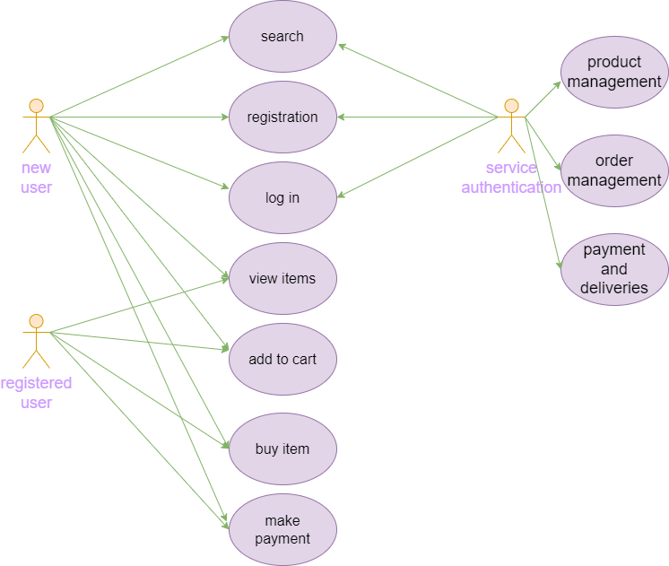

**(4) What is Flow chart? Create a flowchart to make addition of two numbers.**

**-> A flowchart is a visual representation of a process or a set of steps, often used to illustrate how something works or how a task is completed. It uses various shapes and arrows to show the sequence of actions or decisions in a clear and easy-to-follow manner. Think of it as a diagram that provides a visual roadmap, making it simpler to understand and communicate complex processes or algorithms.**

**Flowchart of addition of two numbers :**

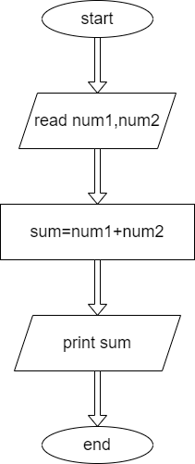

**5) What is Use case Diagram? Create a use-case on bill payment on paytm.**

**-> A use case diagram is a visual summarization of interactions and relationships within a system. In simpler terms, a use case diagram provides a high-level view of who interacts with a system and what actions or tasks they perform. It's a valuable tool for understanding and documenting the functional requirements of a system from a user's perspective.**

